Abstract Submission Template
Due: 12th May, 2019
Title of your AGSCE’19 abstract
First Author’s name¹, co-authors
Email: first_author_email@email.com
¹ Name of University where you study

- Objective (20-80 words)
This is the first sentence of your objective. It should not be longer than 80 words.

- Introduction (max 100 words)
This is the first paragraph of the introduction. The font for this template is 11pt Times New Roman. The Section Headings are bold and is 12pt Times New Roman. The paragraphs are justified and separated by a blank line.

Here is the second paragraph of the introduction. The font for this template is 11pt Times New Roman.

- Method and/or Theory (250-400 words)
Additional instructions are:
- Please write your abstract in English.
- Authors are responsible for sizing and positioning their illustrations.
- Figures can be in black and white or colour.
- The font for this template is 11pt Times New Roman.
- Embed into the text of the paper figures, equations, charts, graphics, etc.
- The resulting MS-Word file MUST be converted to PDF format before submission.
- PDF file size must be less than 2MB.
- PDF file must have all fonts embedded. This can be done via MS-Word using “Save as” and clicking “Options” button and marking “ISO 19005-…’ box.
- Font embedding can be checked by using FILES> PROPERTIES> FONTS in Adobe Acrobat reader. If this is done then all fonts should say “embedded Subset”.
These bulleted items are used as an example and should be deleted so they do not appear in your document.

- Examples (Optional)
This is the first sentence of a second sample section. Each of the paragraphs and section headings appear shaded in this template, with the exception of the bulleted items above and the text in the following figure.

These text boxes appear shaded on the screen only. It will disappear as you select each paragraph to replace with your own text, or just delete.

If you have a chart, graphic, equation, etc. you will need to embed them in the document. You can insert an external file. Here is an example of a figure.

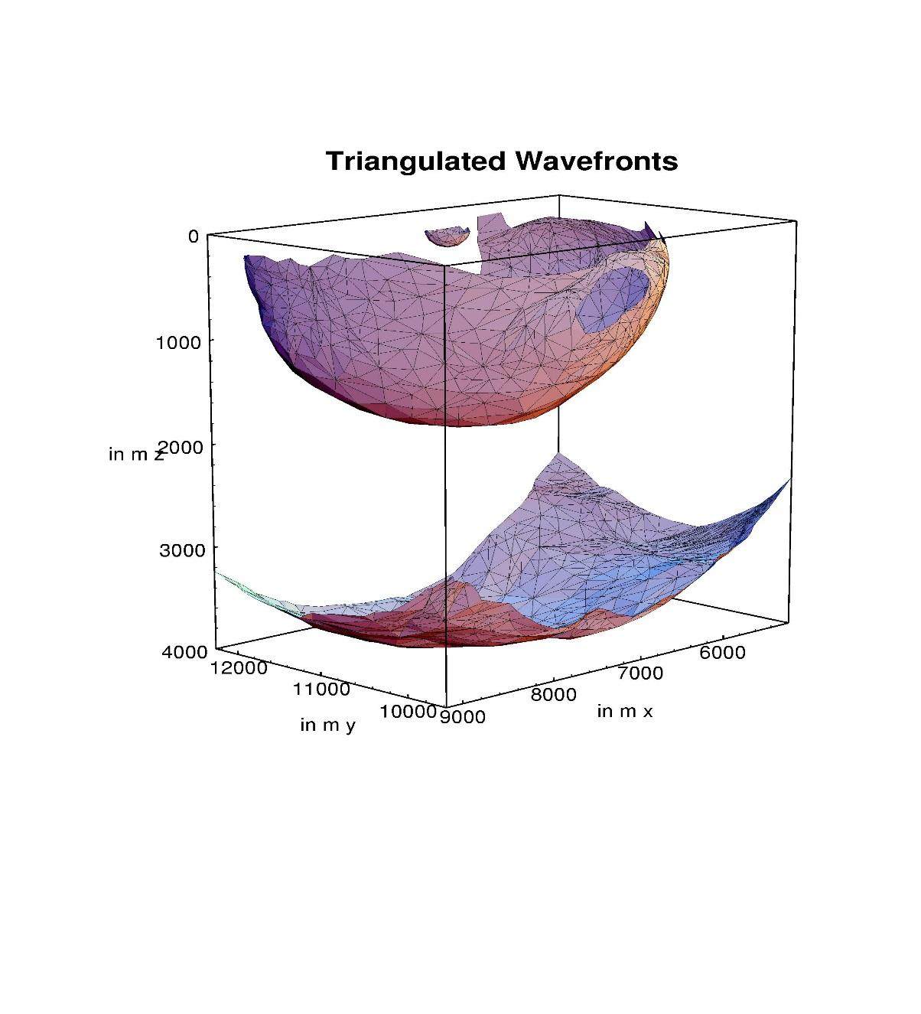
Figure 1 This is an example of a figure imported from jpeg (courtesy of Gilles Lambaré). Left click on Insert on the menu bar and then select Picture. You can also select to embed an object instead of a picture. You can either embed an existing file, or create your object at that point. Number the figures sequentially, according to their appearance in the text, and check that each figure is cited in the text. Supply a short caption for each figure; more detailed discussion of the figure can be reserved for the text. In this template figure caption are 11pt italic Times New Roman.
Example text, please delete if you don't use it.

- Conclusion (max 100 words)
This is the first sentence of the conclusion. Your conclusion should not be more than 100 words.

- References
This is the first sentence of the References section. Please ensure every citation has a reference and vice versa.
For your references: please follow these instructions.
Author (year). Title. Publisher
Example:
Kopka, H. and Daly, P. W. (2004). Guide to LaTeX. Addison-Wesley.

Once completed, please submit your abstract here. Submission deadline is 12th May 2019.

Any questions related to abstract can be directed to:
Email : agsce@utp.edu.my
Whatsapp : +6010 5894642 (Shafika)

